

17th June 2010

LEADFOOTS luncheon – at last

I know it has been a long time and it is way overdue, but the NEXT LEADFOOTS LUNCHEON has been finally booked and will be held at our traditional venue:
Casa Bella Italian Restaurant, 172 Victoria Avenue, Chatswood.
The meeting time is 12.30pm and you need to be there on:
Wednesday, 14th July.

It is interesting that we have been gathering and doing this now for 11 years and the group has grown to become a wonderful amalgamation of people involved and interested in that great 1960s period of motorsport. It is now a fairly large collection of enthusiasts of the era that enjoy the opportunity to meet, eat and discuss a limited range of subjects.
This meeting has no special guest, it is just so that we can get together again – and to get people off my back about “the next LEADFOOTS luncheon”. I promise to do better from now.
Actually, I may have some information about a new art union of interest, and the Tasman Revival that is coming up at the end of the year.
Please remember that it is very important that you indicate your luncheon attendance intentions as soon as possible. Confirmation of non attendance is also helpful, so please let me know either way. The restaurant opens specifically for our occasion and I am required to advise them of numbers for catering. And yes, we certainly do talk about those that fail to communicate appropriately.
See you at lunch,
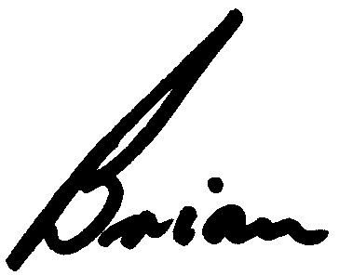

Brian Caldersmith

